**Summary:**

Well, I have completed this major milestone in the IT 312 course here at Southern New Hampshire University. This project develops the dice game, Farkle. I won’t go into explaining the game rules because that is explained in the .txt file when the game is ran. The FarkleGameFP.cpp file is where the main function is executed. A local function called ReadGameRules() reads a .txt file and closes the file to continue with the remainder of the program. Once that .txt file closes, a GamePlay object is decalred and the RunGame() function is called.

I set up the program similar to the course’s milestones such as the Text Adventure game. Therefore, the majority of the program execution is defined in the GamePlay.h and GamePlay.cpp files. RunGame() begins the game by asking the user for the number of players and ensures that there are at least two or more people. Once the names are collected, a player array is established to contain the names of the players. A random number generator is created to represent the each dice roll by the rollDice() function. Each roll is displayed using the displayRoll() function to give the player the option to roll again furing their turn. Also, I created many accesors and modifier functions to obtain the private variable values to maintain the program manageability.

One major error I repeatedely received was a runtime error (shown below). The program would work in the beginning up until I collected the names and the number of players and would unexplicably abort. After searching on the Internet for a solution and running the Visual Studio’s Debugger, I concluded that all of my array values were throwing exception errors because the arrays were not getting sufficient data for my program. I resolved this issue by converting the array variables to pointers as well as the methods that needed to return an entire array. This is the only way to return an array in C++ by returning a pointer to the array; the exception being if I created a vector, which would provide me with more functionality with arrays.

**Please note:** Due to the length and size of GamePlay.cpp, the code snippet was not able to be copied into this Word document. All other files are included.

Example Output:

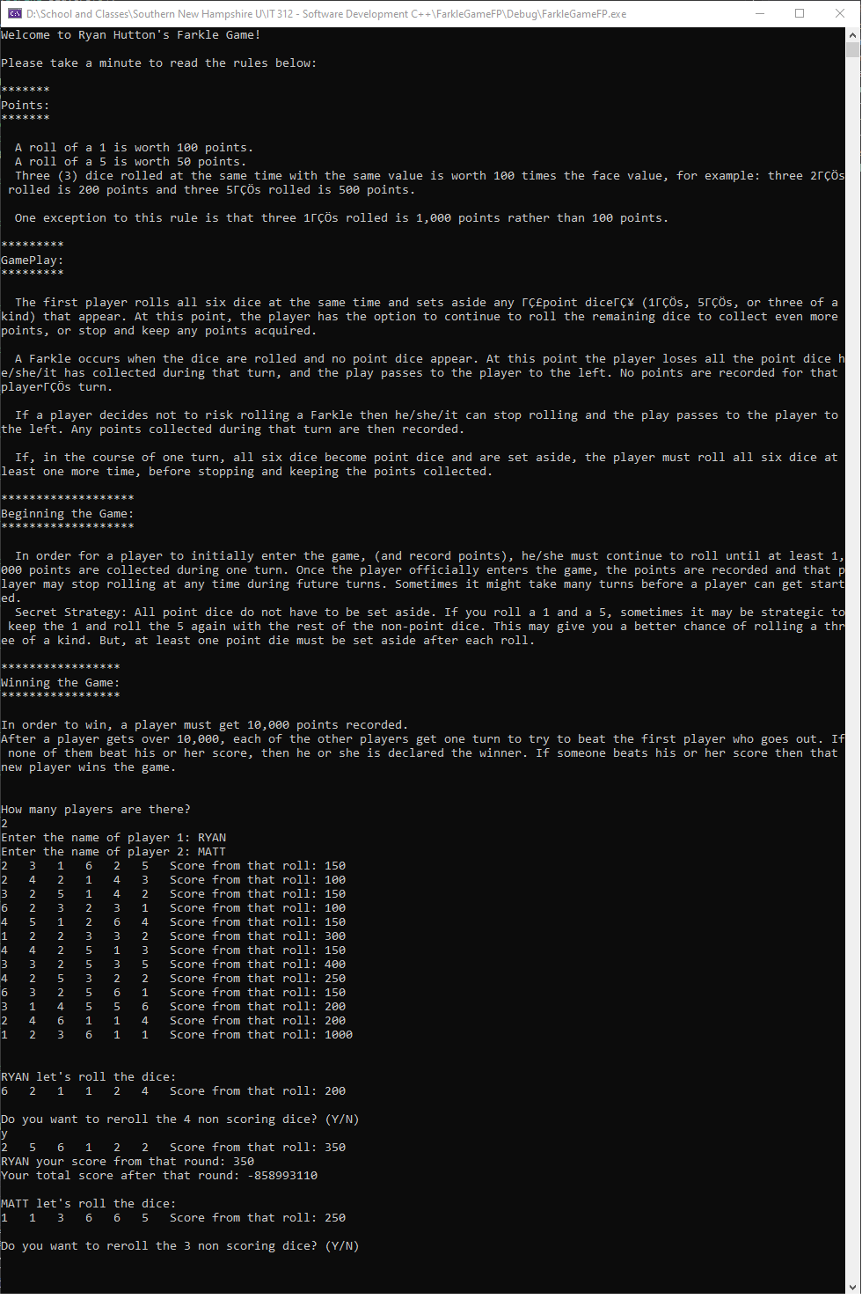

Errors Received:

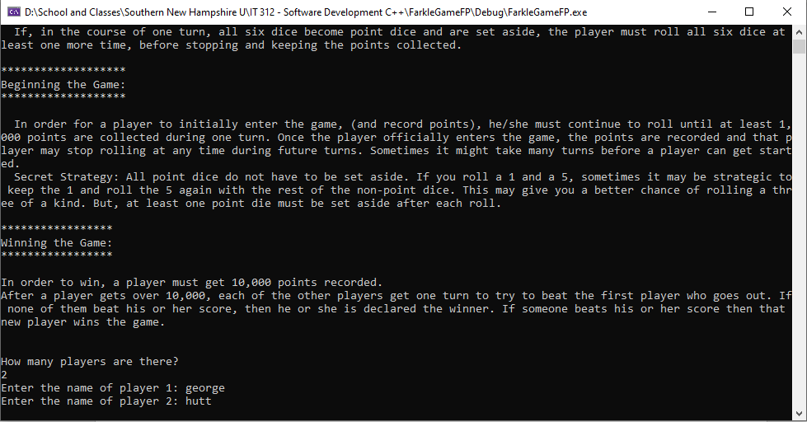

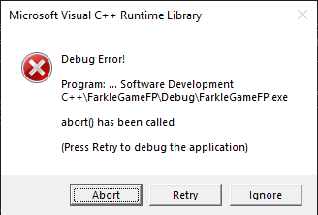

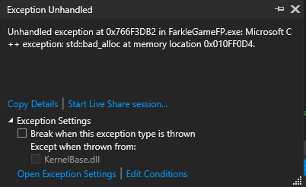

Final Project Code: FarkleGameFP.cpp (main file)

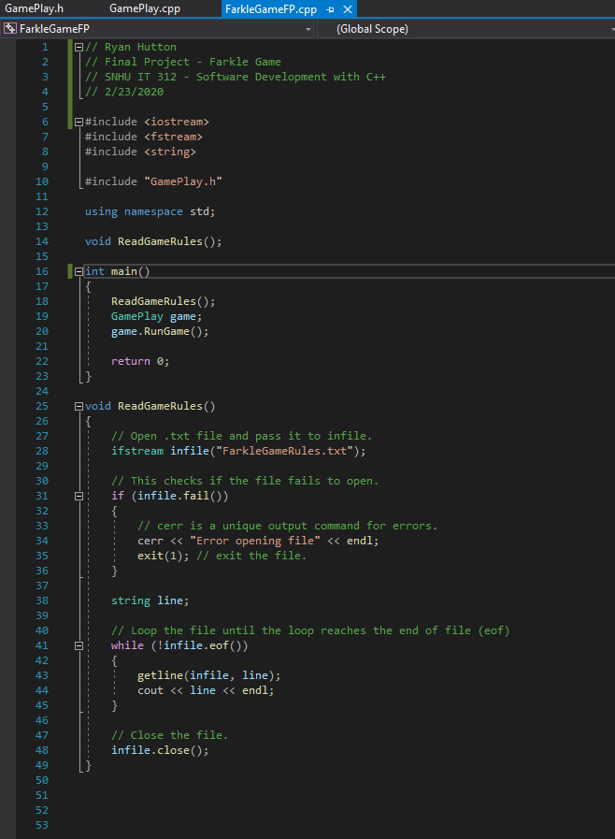

Final Project Code: GamePlay.h

